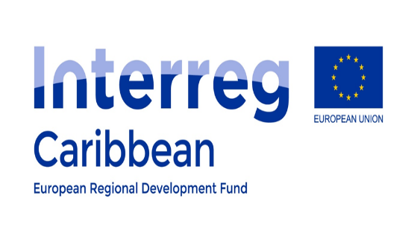
CEREMONIE DE SIGNATURE
SIGNING CEREMONY
Thursday, December 18, 2025
9:00 A.M. – 9:30 A.M.
At the Préfecture de Saint-Martin

STRATEGIE TERRITORIALE DE COOPERATION TRANSFRONTALIERE
ENTRE
SAINT-MARTIN ET SINT MAARTEN
-------------
TERRITORIAL STRATEGY FOR CROSS-BORDER COOPERATION
BETWEEN
SAINT-MARTIN AND SINT MAARTEN

Program

Time | Item | Presenter
8:55 am | Quick 2-minute remarks from the members of the Specific Joint Committee | Reception ensured by Protocol Services
9:00 am | Remarks from the Préfecture de Saint-Martin,  Animator of the Priority Axis 5 | M. Cyrille LE VELY  Préfet  Préfecture de Saint-Martin et de Saint-Barth
9:02 am | Remarks from the Collectivité of Saint-Martin, OR partner | M. Louis MUSSINGTON (SAINT-MARTIN)  Président of the Territorial Council  Collectivité de Saint-Martin
9:04 am | Remarks from Country Sint Maarten, OCT partner | Dr. Luc F.E. MERCELINA (SINT MAARTEN)  Prime Minister  Government of Sint Maarten
9:06 am | Remarks from the Region Council of Guadeloupe,  Managing Authority of the INTERREG Program | M. Patrick SELLIN  Autorité de Gestion INTERREG Caraïbes  Région Guadeloupe et Autorité de Gestion
9:08 am | Remarks from European Commission | Pierre-Emmanuel LECLERC  DG REGIO  European Commission
9:10 am | Remarks from European Delegation | Mme Mariana ARIAS (DG INTPA)  DG INTPA  EU Delegation Barbados
9:15 pm | Signing of the Strategy Document & Official picture with project billboards in background
9:20 am | Press Conference – Questions & Answers
9:30 am | Refreshments  Closing
